PIZZA SALES SQL QUERIES USED
- KPIS
select * from pizza_sales --selecting all datas from the csv file we imported
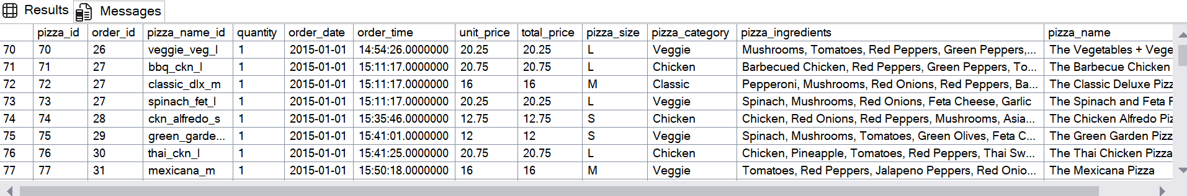

Total Revenue
select sum(total_price) AS Total_Revenue from pizza_sales
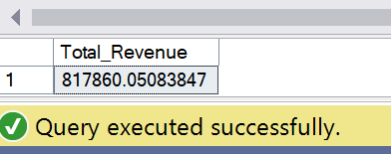

Average sales values
select sum(total_price) / count(distinct order_id) as Average_order_values from pizza_sales --order id is repeating thats y distinct is given
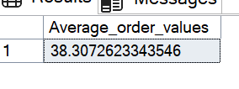
Total pizzas sold
select sum(quantity) as Total_pizzas_sold from pizza_sales
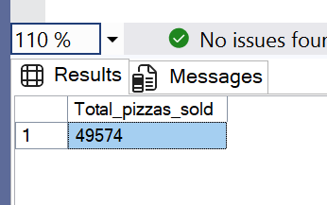

Total number of orders
select count(distinct order_id) as Total_Orders from pizza_sales
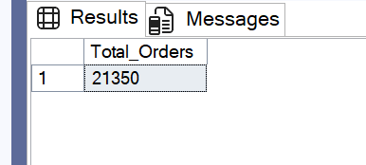

Average pizzas per order
select cast(cast(sum(quantity) as decimal(10,2)) /
cast(count(distinct order_id) as decimal(10,2)) as decimal(10,2))
as Avg_pizzas_per_order from pizza_sales

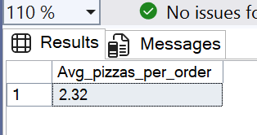

- CHART REQUIREMNT QUERIES
select DATENAME(MONTH, order_date) as Month_name , count(distinct order_id) as Total_orders
from pizza_sales
group by DATENAME(MONTH, order_date)group by DATENAME (dw, order_date)
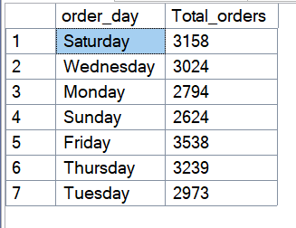

Monthly trend for orders
select DATENAME(MONTH, order_date) as Month_name , count(distinct order_id) as Total_orders
from pizza_sales
group by DATENAME(MONTH, order_date)
order by Total_orders desc
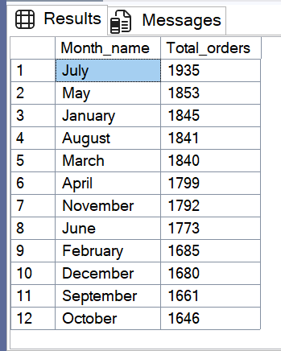

Percentage of total pizza sales by category
select pizza_category, sum(total_price) * 100/
(select sum(total_price) from pizza_sales)
as percentage_total_sales_based_on_category
from pizza_sales
group by pizza_category
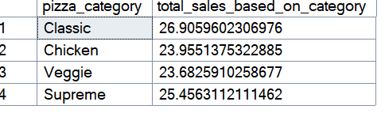

Percentage of sales by pizza size
select pizza_size, sum(total_price) as Total_sales, cast(sum(total_price) * 100/
(select sum(total_price) from pizza_sales) as decimal(10,2))
as percentage_total_sales_based_on_size
from pizza_sales
group by pizza_size
order by percentage_total_sales_based_on_size

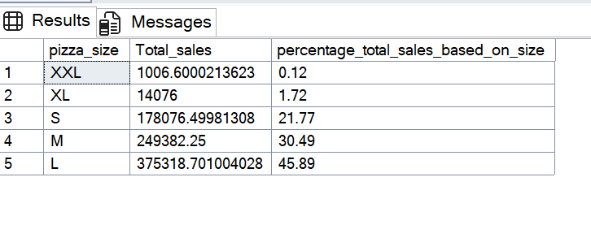
Total pizzas sold by pizza category
select pizza_name, count(distinct order_id) as pizza_sold_each_cate from pizza_sales
group by pizza_name

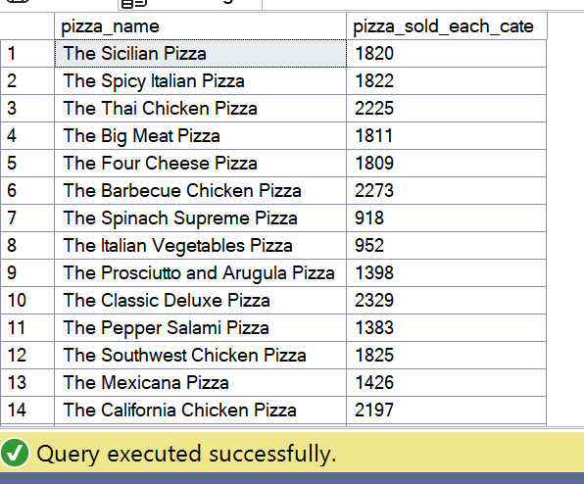

Top 5 best sellers by Revenue
select top 5 pizza_name, sum(total_price) as total_revenue_wrt_pizza_name from pizza_sales
group by pizza_name
order by total_revenue_wrt_pizza_name desc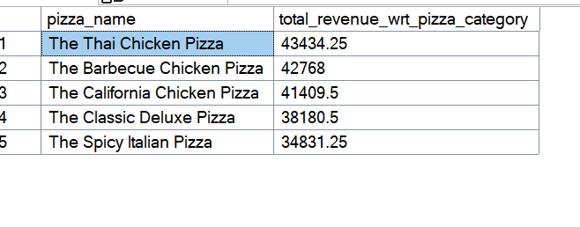
Top 5 best sellers by total quantity
select top 5 pizza_name, sum(quantity) as total_quantity_wrt_pizza_name from pizza_sales
group by pizza_name
order by total_quantity_wrt_pizza_name desc
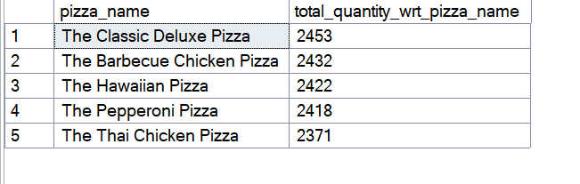

Top 5 best sellers by total orders
select top 5 pizza_name, count(distinct order_id) as total_orders_wrt_pizza_name from pizza_sales
group by pizza_name
order by total_orders_wrt_pizza_name desc
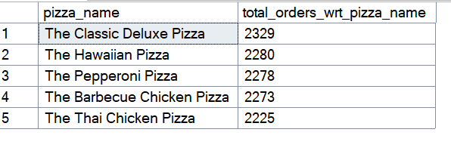
worst 5 best sellers by Revenue
select top 5 pizza_name, sum(total_price) as total_revenue_wrt_pizza_name from pizza_sales
group by pizza_name
order by total_revenue_wrt_pizza_name asc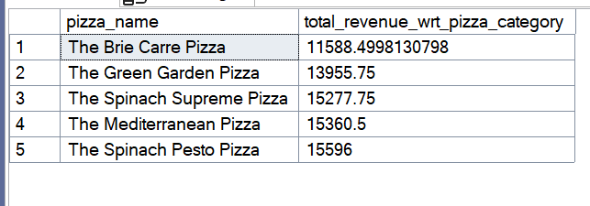

worst 5 best sellers by total quantity
select top 5 pizza_name, sum(quantity) as total_quantity_wrt_pizza_name from pizza_sales
group by pizza_name
order by total_quantity_wrt_pizza_name asc

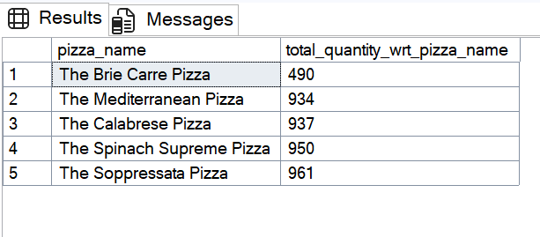
worst 5 best sellers by total orders

select top 5 pizza_name, count(distinct order_id) as total_orders_wrt_pizza_name from pizza_sales
group by pizza_name
order by total_orders_wrt_pizza_name asc

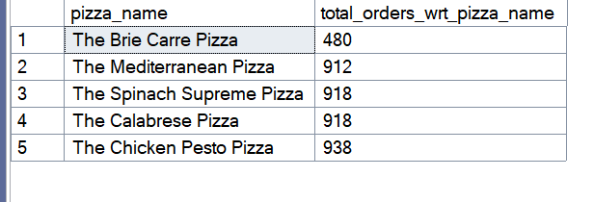
NOTES
Percentage of total pizza sales based on pizza category on January month
select pizza_category, sum(total_price) * 100/
(select sum(total_price) from pizza_sales where MONTH(order_date)=1)
as percentage_total_sales_based_on_category
from pizza_sales
where MONTH(order_date)=1
group by pizza_category
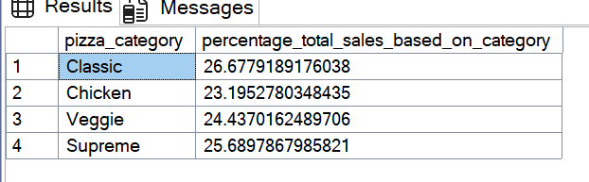

Sales by pizza size on quarter 1

select pizza_size, cast(sum(total_price) as decimal(10,2)) as Total_sales, cast(sum(total_price) * 100/
(select sum(total_price) from pizza_sales WHERE DATEPART(quarter, order_date)=1) as decimal(10,2))
as percentage_total_sales_based_on_size
from pizza_sales
WHERE DATEPART(quarter, order_date)=1
group by pizza_size
order by percentage_total_sales_based_on_size desc

